Changing your password on college computers
for students
How to reset your password from any computer in the college

You can reset your password from any computer in the College.
Please follow the instructions below:
- Login to the computer using your current username and password.
- Once you're logged in, press Ctrl + Alt + Delete together
- Choose Change a Password.

- 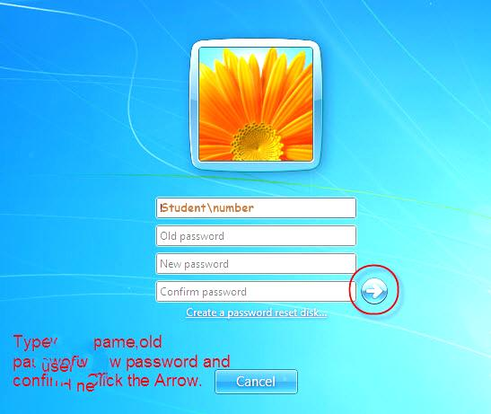On the Next Screen shown below

- You will be asked to enter your Old Password.
- You will then need to enter your new password.
- Then confirm the new password.

Your password must have at least 8 characters include one Capital letter and one Number. Example: (Jankano7)

- When all set, click on the arrow or hit Enter and your password is changed.

Please note that your password changes for Moodle also.

