e-Learning Developer, Digital Content Supervisor – Jaguar Land Rover Academy Warwi... E-learning Content Developer X2 -Learning Technologist, technology Enhanced Learning (TEL) Manager -, E-learning Designer

1.56

.37 Agriculture and forestries, .53 mining and extraction, 1.4 transport and storage.

Also I was asking around my class and I found out that a lot of peoples parents do not even know how to use a computer I was thinking more about a short course I could run and if it would be possible to ask the principal for a timeslot in a room after a certain time such as after 5pm so parents could come after work and learn about the basics of computing and it would cost them nothing as it would be just be me teaching a room for of adults for free

Questions to ask.

The first question could be worded different as some of the parents may not understand tech talk so it could be worded How do you use Ict Or how do you use your computer

2nd question could be How commutable are you using the computer

and a question could be what do you think about when you think about online dangers or what do you think your kids use the internet for also you could ask and l

astly and to find out there knowledge of the computer ask them how often do you use your computer or a device such as a smart phone (that way you can figure out how much time they spend on these things to see how useful this might be to them

Want to get an idea of their own use of IT (what term? ICT), assessment of own abilities, whether –and to what extent- they have an appetite to improve and in what way that the college can help you.

Own use (multiple choice allow many answers)
Social Media
Email
Documents e.g. letters
Shopping
Research (holidays, travel, events)
Skype / Facetime
Other
Barely at all.

Assess own use / ability –
Confident
Able to help son / daughter
Would like to know more / feel could help more

Do you have desire to improve yes / no

Rate your desire to improve out of 5

What could the college do to help you?

Understand college uses of ICT
Improve your skills via a course
Access some of the college systems e.g. ProPortal

Open Text – anything in particular you feel you’d like to learn?

What would help you most?

Scripting for film

Introduce Digital Economy, Footprint, Government Agenda
My job and changing employment.
IT job in general – research list get data – IT students to talk about this.

-link so that’s one sector

However.
Business / Administration / Office work

Cuts across all areas examples from tourism, science, sports, construction, health care, creative

BASIC ICT is just an established minimum when it comes to employability

Ben to talk…

Apply for a job online
Promote yourself or your business online

More learners?

Back to me.

We think it may help our students if we help you so you can help each other?

Research.

UK's digital industries growing 32pc faster than wider economy Telegraph www.telegraph.co.uk › Finance › Business Club › Technology. 11 Feb 2016

Britain's technology sector as "extraordinary", after a report revealed companies are generating £161bn for the economy.
According to the Tech Nation report, now in its second year, the digital economy grew 32pc faster than the rest of the economy between 2011 and 2014, and is creating new jobs at an unprecedented rate.
The sector accounts for 1.56m jobs across the UK, with this workforce growing by more than 10pc over the three-year period - three times faster than the wider UK job market.

App and software development is the fastest-growing niche in the digital economy, growing by 17pc overall in 2015, it found.
Data companies and hardware manufacturers also posted growth of more than 10pc.
Around two-thirds of technology businesses are based outside London and the research pinpointed 27 "notable" digital clusters across the UK.

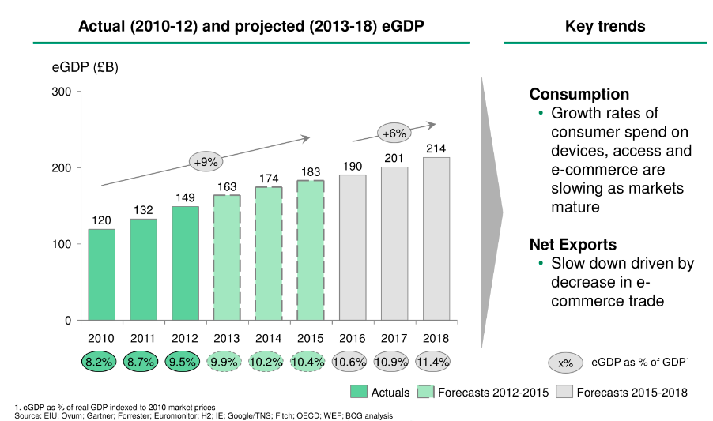

https://www.techuk.org/insights/news/item/4075-uk-s-digital-economy-is-world-leading-in-terms-of-proportion-of-gdp

https://www.bcg.com/d/press/1may2015-internet-contributes-10-percent-gdp-uk-economy-12111
LONDON—The UK has retained its position as the largest Internet economy in the G-20, according to research released today by The Boston Consulting Group (BCG). The sector has seen strong growth since 2010, but fresh digital-policy commitments are needed to ensure this trend continues.

The Internet is now the UK’s second-biggest economic contributor behind the property sector, having overtaken manufacturing and retail. BCG expects the Internet economy to contribute £180 billion to the overall economy in 2015, up from £120 billion in 2010. At 10 percent of gross domestic product (GDP), this is a larger percentage than in any other G-20 country. By 2016, the Internet economy will be contributing 12.4 percent of GDP in the UK, compared with a G-20 average of 5.3 percent.

“Among G-20 countries, the UK’s digital economy is the largest as a proportion of GDP, and we expect the UK to retain its position,” said Paul Zwillenberg, a BCG partner and digital economy expert. “The Internet economy in the UK, which includes online retailing, sales of Internet-related devices, IT and telecommunications investments, and Internet-related government spending, is expected to grow to more than £200 billion over the life of the next government and to double in size from 2010. But other G-20 members with rapidly growing online-retail sectors, such as China and South Korea, are closing the gap. The UK needs fresh digital initiatives and a new type of ‘Twenty-First Century Industrial Strategy’ to ensure these strong growth trends continue to provide jobs and boost the UK economy over the course of the next parliament.”

Report https://www.gov.uk/government/uploads/system/uploads/attachment_data/file/492889/DCMSDigitalSkillsReportJan2016.pdf

The ‘digital economy’ is a widely used phrase. The UK government defines it to include the following sectors:

Manufacture of computer and digital equipment
Wholesale of computer and digital equipment
Publishing activities
Software publishing
Media production (including TV, film, music)
Telecommunication activities
Computer programming activities
Data processing
Repair of computers and digital equipment

Statistical summary:

The digital economy employed 1.3 million people in 2014, 5% of all employees in Great Britain.
There were 204,000 digital economy businesses, 9% of the UK total in 2015.
The economic contribution of the digital economy in terms of Gross Value Added was £118 billion, 7% of the UK total in 2014.

http://researchbriefings.parliament.uk/ResearchBriefing/Summary/CBP-7610

Job options – How many do you recognise? Computer Programmer degree
Jobs directly related to your degree include:

Application analyst
Business analyst
Data analyst
Database administrator
Games developer
Information systems manager
IT consultant
Multimedia programmer
SEO specialist
Systems analyst
Systems developer
UX analyst
Web designer
Web developer
Jobs where your degree would be useful include:

Digital copywriter
IT sales professional
IT trainer
Network engineer
PPC specialist
Product manager
Secondary school teacher
Social media manager
Technical author
UX designer

Archivist
Cartographer
Computer games developer
Computer games tester
Computer service and repair technician
Database administrator
Data entry clerk
E-learning developer
Forensic computer analyst
Helpdesk professional
Indexer
Information scientist
IT project manager
IT security coordinator
IT support technician
IT trainer
Librarian
Library assistant
Measurement and control technician
Media researcher
Network engineer
Network manager
Office equipment service technician
Operational researcher
Pre-press operator
Security service personnel
Software Developer
Systems analyst
Technical architect or IT systems architect
Technical author
Telephonist-switchboard operator
Web content manager
Web designer
Web developer
Web editor

ormation Technology (IT) Job Titles
A - D

Application Developer
Application Support Analyst
Applications Engineer
Associate Developer
Chief Technology Officer (CTO)
Chief Information Officer (CIO)
Computer and Information Systems Manager
Computer Systems Manager
Customer Support Administrator
Customer Support Specialist
Data Center Support Specialist
Data Quality Manager
Database Administrator
Desktop Support Manager
Desktop Support Specialist
Developer
Director of Technology
E - N

Front End Developer
Help Desk Specialist
Help Desk Technician
Information Technology Coordinator
Information Technology Director
Information Technology Manager
IT Support Manager
IT Support Specialist
IT Systems Administrator
Java Developer
Junior Software Engineer
Management Information Systems Director
.NET Developer
Network Architect
Network Engineer
Network Systems Administrator
P - S

Programmer
Programmer Analyst
Security Specialist
Senior Applications Engineer
Senior Database Administrator
Senior Network Architect
Senior Network Engineer
Senior Network System Administrator
Senior Programmer
Senior Programmer Analyst
Senior Security Specialist
Senior Software Engineer
Senior Support Specialist
Senior System Administrator
Senior System Analyst
Senior System Architect
Senior System Designer
Senior Systems Analyst
Senior Systems Software Engineer
Senior Web Administrator
Senior Web Developer
Software Architect
Software Developer
Software Engineer
Software Quality Assurance Analyst
Support Specialist
Systems Administrator
Systems Analyst
System Architect
Systems Designer
Systems Software Engineer
​T - Z

Technical Operations Officer
Technical Support Engineer
Technical Support Specialist
Technical Specialist
Telecommunications Specialist
Web Administrator
Web Developer
Webmaster

Retail and Hospitality
Grocery and department store retail sales associates use computers to access customer accounts and records. For example, many grocers have rewards programs that offer discounts to registered shoppers who frequent the store. Cashiers might have to enter the customer's telephone number or other identifying information into a computer database to access and apply the customer's rewards points. At hotel chains, locations around the country use computerized reservations systems linked to a corporate headquarters, as well as online room-booking websites.

Health Care
Allied health care jobs can include medical transcriptionists, radiologic and ultrasound technologists. Clinics and hospital systems rely on allied health professionals to collect patient information and diagnostics. For example, medical transcriptionists enter patient information into computer databases called electronic medical records. Afterward, doctors and nurses use computer terminals to access the EMR database, make a diagnosis and prescribe a course of treatment.

Construction
Although construction workers spend much of their time building with their hands, computers play an important role in this field as well. The construction profession relies on global positioning systems, electronic surveying equipment and geographic information systems. It is not strange to see a construction site supervisor using a heavy-duty, weather-resistant laptop outdoors. Contractors might also use construction estimating software programs to help make a reasonable and educated bid for a new project.

Financial Services
Commercial banks, local credit unions and credit card companies all rely on computers to deal with financials for consumers and businesses. When customers make deposits into their bank accounts at local branches, tellers enter the dollar amounts into a computer database. Afterward, customers often have access to online banking and credit card account management that is hosted on the financial institution's computer servers online. Customer service agents may have access to this same database when helping customers over the telephone.

Play Computer job bingo game? https://www.thebalance.com/list-of-information-technology-it-job-titles-2061498 job titles list

Really good list of general job skills https://www.thebalance.com/list-of-general-skills-2063753

