Microsoft 365 Office Online – Immersive Reader and Translation. .

Step One: Getting to 365
Type http://portal.office.com (or https://login.microsoftonline.com/login.srf ) into your address bar.

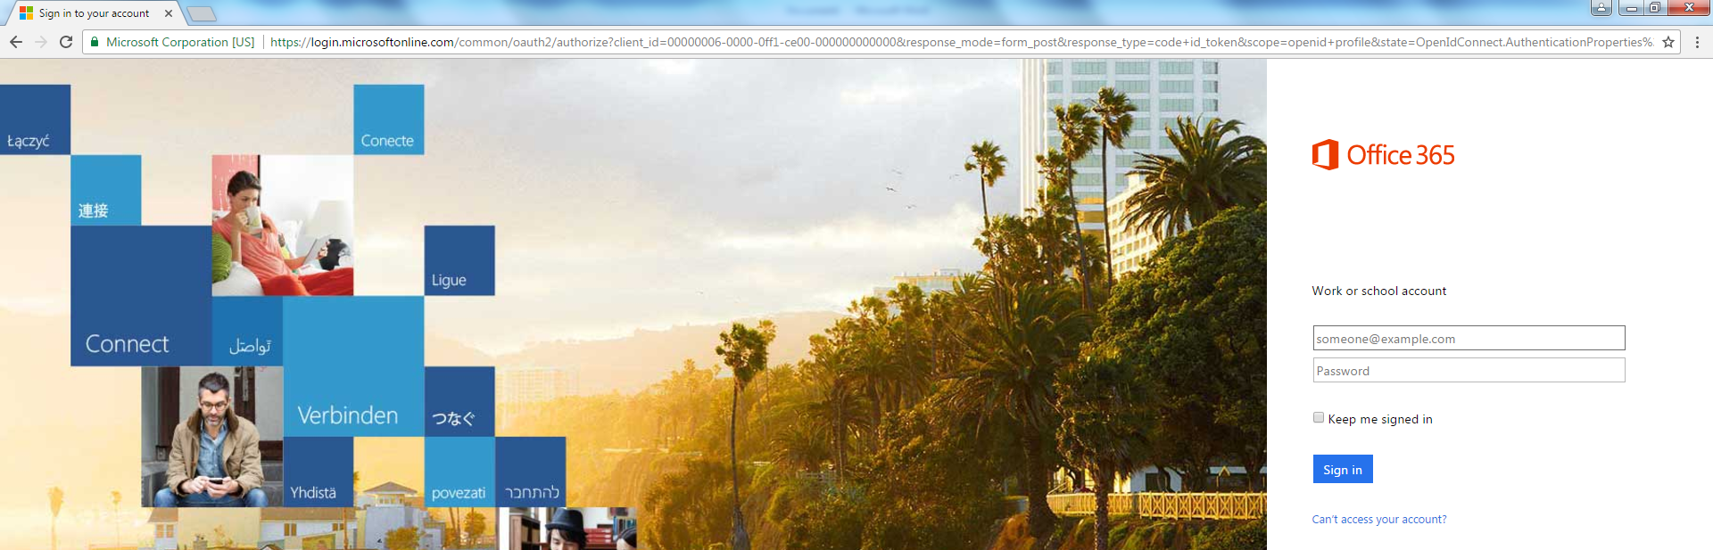

Step Two: Logging in to 365

Login with your Lambeth College email* account username ( e.g. croberts@lambeth.ac.uk ) and password. Note @lambeth not @lambethcollege.
For students it’s 88888888@student.lambeth.ac.uk

Outside the college or using Google Chrome you’ll have to do this twice but inside –once you’re logged on it should go straight through to the Office Portal.

Step Three : Uploading a file to One Drive

Select One Drive . Upload a file.

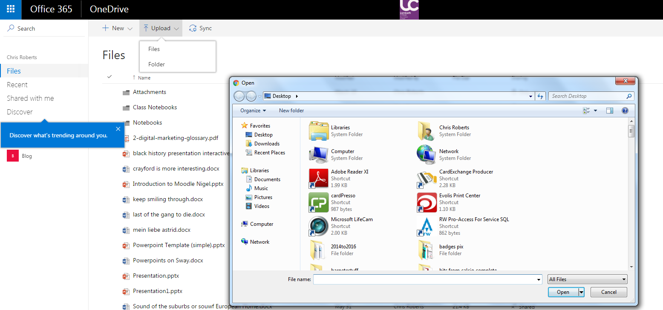

Step Four – Immersive Reader

Select your file from One Drive and open.

Select edit in browser (Note at this point Microsoft may update your document to a version compatible with Immersive Reader.)

Step Six . Finding the reader.

Go to View then Immersive Reader

Step Seven: Use the features

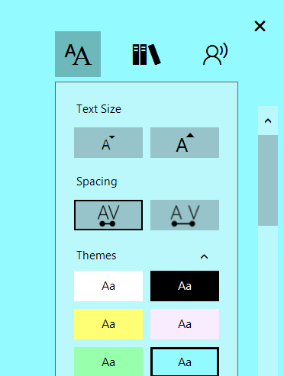 | Text viewing  Change the size of text  Change the width of text  Add a colour background
Text analysis.
Break up words in to Syllables

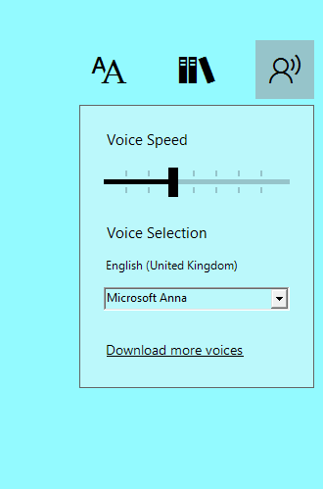 | Read out loud.  This is useful for learners with poor reading skills, who do not have English as a first language.  For a more advanced level of learner it is an excellent proof reading tool and all learners should be encouraged to read their assignments back this way prior to handing in

New Feature ! Picture Dictionary.

Go to reading preferences and make sure picture dictionary is on.

It doesn’t work for all words but if you click on a word it’ll reveal a picture especially with nouns.

