Teams – getting there for students

Access via 365.

Log on on to 365 ( https://www.office.com/ ) Student IDNUMBER@student.lambeth.ac.uk
Select Teams App

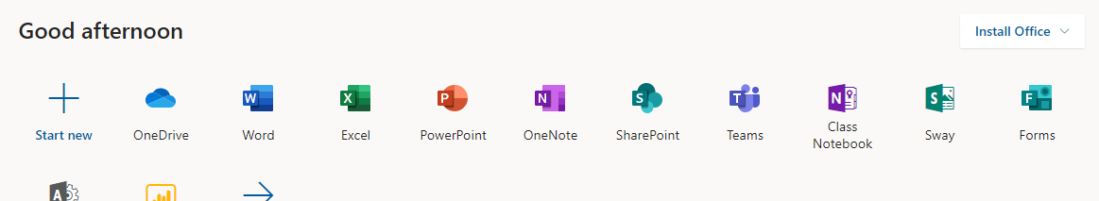

Go to the relevant team

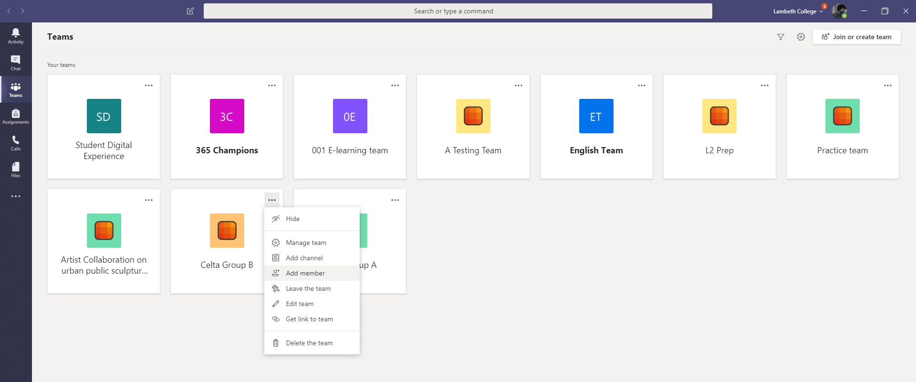

Access via desktop
From 365 the App can be downloaded onto your desktop.
Search for download microsoft teams on any search engine or go to
https://products.office.com/en-gb/microsoft-teams/download-app

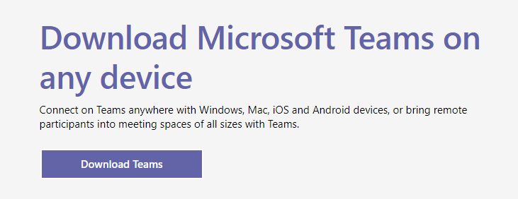 | This will place a link onto your desktop which, once you have logged in, will take you directly your team(s).

Access via phone app

Either as above using a browser or go directly to app store ( or playstore) and download relevant app.

In both these last cases make sure you log in correctly.

Student IDNUMBER@student.lambeth.ac.uk

